Introduction to Claude Code & Software Engineering with AI Agents Apr 29, 2026
This course item introduces the transformative impact of Generative AI, specifically Claude Code by Anthropic, on software engineering, enabling developers to build complex applications rapidly and at scale.
Generative AI in Software Engineering
- Claude Code can autonomously build complete applications, such as a Next.js expense tracker, in minutes, a task that traditionally takes days or weeks with a team.
- It plans, codes, and tests software with minimal input, handling requirements and coordination that would otherwise slow down human teams.
Advantages of Claude Code
- It simulates the productivity of a large, perfectly coordinated development team, delivering results much faster than conventional methods.
- The tool produces well-structured, functional, and visually appealing applications without detailed initial requirements.
Changing Developer Roles and Skills
- The use of Claude Code shifts the developer's role from writing individual code pieces to managing and orchestrating AI-driven development.
- The course will explore new essential skills, workflows, and quality assurance processes needed to work effectively with AI in software development.
1000X Improvement in Software Engineering Productivity with Big Prompts Apr 29, 2026
The main idea of this course content is to rethink how we use generative AI for software engineering by moving away from micromanaging code generation and instead leveraging AI's ability to scale and handle large tasks autonomously.
Micromanagement vs. Scalable AI Use
- Micromanaging AI by prompting it to write individual functions or files limits its potential and creates bottlenecks.
- Treating AI like a team member who can handle big tasks and build entire features leads to much greater productivity gains.
Examples of Scalable AI Prompting
- Small-scale prompts focus on specific code pieces, akin to a manager assigning every tiny task, which is inefficient.
- Large-scale prompts ask AI to think like a user and build comprehensive features, enabling it to innovate and produce complex software autonomously.
Benefits of High-Level AI Delegation
- AI can create advanced features, analytics, and UI improvements without step-by-step instructions.
- This approach can yield up to 1000X productivity improvements compared to traditional coding or micromanaged AI coding.
Key Takeaway for Software Engineers
- Avoid being the bottleneck by stepping back from micromanaging AI.
- Embrace higher-level abstraction and delegate big tasks to AI, focusing human effort on critical thinking, architecture, and innovation.
An Important Note on Costs Apr 29, 2026
This course content explains the usage and cost considerations of Claude Code, an AI-assisted software development tool.
Subscription and Payment Options
- Claude Code can be accessed via a monthly subscription with daily/monthly usage limits.
- Alternatively, users can connect Claude Code to an API key and pay based on actual token usage.
Cost Management and Usage Tips
- Exercises in the course can consume significant token costs, potentially $50+ if all exercises are completed.
- Users are advised to track token usage carefully and consider whether a subscription or pay-as-you-go model is more cost-effective.
- Setting limits on token usage, such as avoiding auto-recharge, is recommended to control expenses.
Personal Experience and Best Practices
- The instructor finds monthly subscriptions cheaper than manual work and uses token limits as natural breaks for reflection.
- For institutional use, token costs are paid directly, emphasizing the importance of managing usage efficiently.One Software Engineer to Another: Let's Talk About the Fear Apr 29, 2026
This course content shares a personal perspective on how generative AI, specifically Claude Code, is transforming software engineering by enhancing creativity, productivity, and enjoyment in coding.
Personal Journey and Initial Concerns
- The speaker has a deep passion for coding and has experience with many programming languages.
- Initially, the arrival of AI tools that can write code faster and better caused fear and sadness about the future of software engineering.
Transformation Through Claude Code
- Using Claude Code to build entire applications and features shifted the focus from debugging and minutiae to creative problem-solving.
- The speaker experienced unprecedented joy, creativity, and higher quality and velocity in software development.
The New Role of the Software Engineer
- Creativity, critical thinking, design knowledge, and architecture remain essential skills.
- AI tools like Claude Code enable developers to realize ambitious ideas quickly, making software engineering more inspiring and fun.

AI Labor: Claude Code is an AI Development Team Apr 29, 2026
This course content explains the importance of thinking about AI, specifically Claude Code, as scalable labor in software engineering rather than just a tool for small tasks.
AI as Scalable Labor
- AI agents like Claude Code perform software engineering labor autonomously, doing work on your behalf beyond simple prompt-response tasks.
- Bigger prompts enable leveraging AI labor at scale, allowing AI to work on large tasks independently rather than micromanaging small pieces.
Leadership and Prompting Strategy
- Instead of micromanaging AI like a single coworker, think of yourself as a leader managing many AI developers by giving broad, challenging tasks.
- Effective prompts provide vision and context, encouraging AI to solve problems creatively and consistently across the project.
Course Focus and Goals
- The course will teach how to task AI labor effectively in software engineering, scale its use, and address challenges unique to AI-assisted development.
- Cloud Code is presented as an AI agent team that can work in parallel on multiple features, helping you multiply productivity while maintaining quality.
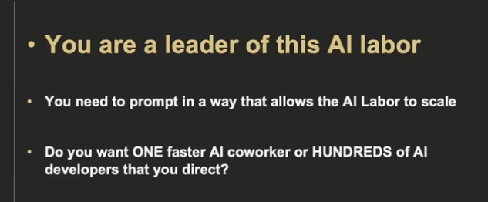

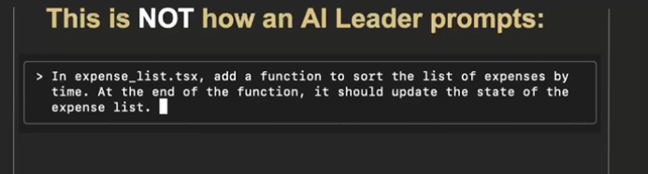

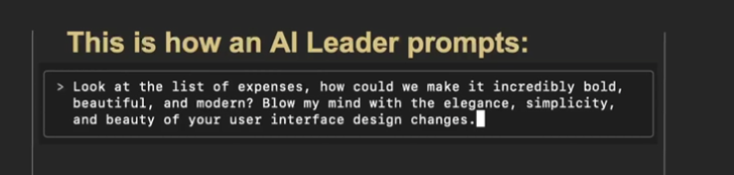
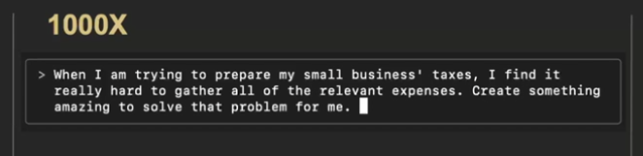

The Best of N Pattern: Leverage AI Labor Cost Advantages Apr 29, 2026
This course content focuses on leveraging AI, specifically Claude Code, to enhance software engineering by scaling development labor and improving code quality through iterative and creative approaches.
AI Labor and Code Quality
- AI code quality depends significantly on how prompts are crafted and other techniques beyond prompting.
- Developers must remain actively involved in architecture and design to ensure high-quality software.
Scaling Software Development with AI
- AI enables rapid exploration of multiple design alternatives, which is often too costly with traditional human labor.
- By generating multiple versions of a feature or application, AI allows comparison, evaluation, and selection of the best solutions.
Creative Problem Solving and Iteration
- AI can produce diverse and innovative solutions without bias or fatigue, enabling developers to discover novel approaches.
- Developers can cherry-pick desirable elements from different AI-generated versions to combine and refine the final product.
Cost and Efficiency Benefits
- AI labor is fast and cost-effective, capable of producing complex features in minutes at a fraction of traditional costs.
- This scalability allows for experimentation and iteration that was previously impractical, enhancing critical thinking and design quality.
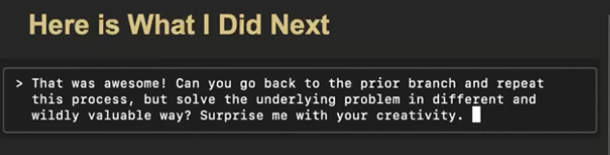

Exercise: Build Multiple Versions of a Feature with Best of N Apr 29, 2026
This course content focuses on implementing the "Best-of-N" pattern in software development using Claude Code, an AI-assisted coding tool, by building multiple versions of a data export feature in a NextJS expense tracker app.
Understanding the Best-of-N Pattern
- The Best-of-N pattern involves creating 3-5 different implementations of a feature using AI, then comparing and selecting the best one.
- This approach leverages AI's speed, low cost, creativity, and lack of ego, allowing rapid iteration and experimentation beyond traditional development constraints.
Implementing Multiple Versions of Data Export
- Version 1: A simple CSV export with a basic "Export Data" button that downloads expenses as a CSV file using straightforward browser APIs.
- Version 2: An advanced export system with a modal offering multiple formats (CSV, JSON, PDF), filtering options, data preview, custom filenames, and loading states for a professional user experience.
- Version 3: A cloud-integrated export system simulating email export, Google Sheets integration, backup scheduling, export history, sharing features, and integration mockups with cloud storage services, focusing on modern SaaS-style connectivity and collaboration.
Version Control and Workflow
- Each version is developed on a separate git branch starting from a clean state to keep implementations isolated.
- The process includes creating branches, implementing features, testing, and committing changes.
- Learners can switch between branches to compare and test different implementations easily.
Can AI Judge Code Quality? Apr 29, 2026
This course content focuses on evaluating and improving code quality using AI, specifically Claude Code, by establishing trust in its ability to produce high-quality code.
Code Evaluation and Scoring
- Claude Code can generate a detailed rubric with multiple criteria such as functionality, error handling, code quality, flexibility, performance, documentation, security, maintainability, line efficiency, and best practices.
- It can apply this rubric to score different code solutions, providing rationales for its evaluations, such as preferring code with type hints or comprehensive error handling.
Contextual Understanding in Evaluation
- The evaluation of code quality depends heavily on context, such as project requirements and best practices.
- When given specific context (e.g., historical logging system requirements), Claude Code adjusts its scoring to reflect priorities like exception throwing and timestamp flexibility.
Self-Critique and Improvement
- Claude Code can critique its own code and suggest improvements based on the rubric and context.
- This capability enables iterative refinement of code to meet quality standards and project-specific needs, helping to close gaps in consistency and quality in AI-generated code.
Exercise: AI Evaluation of Code & Feature Implementations Apr 29, 2026
This course item focuses on systematically evaluating multiple AI-generated implementations of a software feature to make informed development decisions.
Why Code Evaluation Matters for AI Development
- AI development enables creating multiple working solutions quickly, unlike traditional development which usually builds one version.
- The challenge is to systematically compare these implementations based on real code and user experience rather than theoretical alternatives.
Setting Up for Systematic Evaluation
- Verify you have all three feature implementations in separate git branches.
- Use Claude Code to switch between branches and analyze code architecture, UI design, technical approaches, and trade-offs.
Conducting the Evaluation
- For each implementation, examine files changed, code organization, components, libraries, error handling, and performance.
- Document findings in a structured "code-analysis.md" file covering technical details, complexity, security, and maintainability.
Review and Customize Evaluation
- Review Claude's analysis to understand differences in architecture and implementation philosophy.
- Create a personalized evaluation template focusing on criteria important to your projects and team for future comparisons.
Does AI Labor Understand Design Principles? Apr 29, 2026
This course content discusses how AI, specifically Claude Code, can understand and apply high-level software design principles to produce high-quality code efficiently.
Understanding AI and Design Principles
- Claude Code can comprehend complex design principles like the SOLID principles, which include single responsibility, open-closed, Liskov substitution, interface segregation, and dependency inversion.
- Using well-known design principle names as instructions is token-efficient and powerful, allowing AI to expand these into detailed coding guidelines without needing exhaustive rule lists.
Applying Design Principles with Claude Code
- Claude Code can refactor code to align with design principles such as SOLID, creating modular, object-oriented components with single responsibilities.
- This capability enables the AI to produce code that is extensible, reusable, and maintainable, reflecting professional software engineering standards.
Leveraging AI for High-Quality Code Production
- Providing Claude Code with sufficient context and clear quality criteria allows it to self-assess and generate consistent, high-quality code.
- Emphasizing fundamental design principles in instructions helps maximize AI productivity and code quality, reducing the need for micromanagement and detailed rule specification.
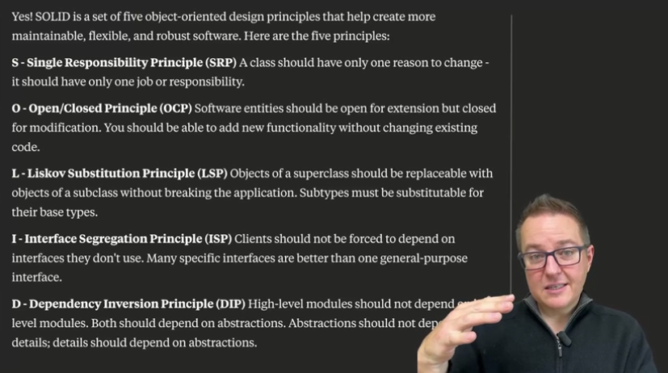

Chat, Craft, Scale: Spend More Time Designing & Innovating Apr 29, 2026
This course content focuses on the evolving role of software engineers in the era of generative AI, emphasizing the importance of design and architecture over just writing code.
The challenge of generative AI coding
- Generative AI can produce code with high variability, so engineers must guide the direction and architecture.
- Simply giving big prompts to AI is not enough; thoughtful design and iteration are crucial.
The shift in software engineering practice
- Engineers need to spend more time on design, refactoring, and improving code quality.
- The goal is to achieve higher quality applications, not just faster development.
The "Chat, Craft, Scale" approach
- This system emphasizes the intellectual and creative aspects of working with AI.
- The course will first focus on "chat" and "craft" before exploring how to scale AI labor in software development.
Chat: Craft and Explore Requirements & Options Apr 29, 2026
This course content focuses on using chat-based interactions with Claude Code to enhance software design and development processes.
Design Thinking Through Chat
- Chatting with Claude helps explore various design dimensions and encourages critical thinking about different approaches.
- It aids in thoroughly thinking through requirements before starting development, ensuring the project is well-directed.
Requirements Gathering with AI Assistance
- Claude Code can generate comprehensive lists of software requirements, covering functionality, security, task management, and developer experience.
- This helps identify missing or overlooked requirements early, improving the completeness of the design.
System and Interface Design
- After defining requirements, the next step is designing system interfaces, such as HTTP API routes.
- Chatting with Claude supports refining these designs to ensure alignment with requirements and completeness before implementation.
Chat: Rapid Prototyping & Personas Apr 29, 2026
This course content focuses on designing and prototyping APIs using AI, specifically leveraging a large language model (Claude) to simulate and test API designs before actual implementation.
API Design Approaches
- Three different REST API design styles are proposed: resource-oriented, action-oriented, and a hybrid task-focused approach.
- Each design style has trade-offs in terms of usability, standardization, and support for use cases like file uploads and batch operations.
Identifying Design Limitations
- The AI helps identify potential friction points and limitations in the API design, such as file upload timing issues, race conditions, and lack of batch operation support.
- This analysis helps perform a gap assessment to refine the API design before coding.
Rapid Prototyping with Persona Pattern
- The persona pattern is used to have the AI take on the role of the API server, simulating HTTP requests and responses.
- This allows rapid proof-of-concept testing and iteration of the API design without writing any code.
- The approach helps catch design flaws early, avoiding wasted effort on building flawed implementations.
Craft: Constraints & Prompts for Claude Code Apr 29, 2026
This course content focuses on the practical implementation phase of software development using AI assistance, specifically with Claude Code.
Crafting the Implementation
- Emphasizes the importance of developer craftsmanship in choosing libraries, structuring folders, configuring, and deploying code.
- Highlights the value of designing ergonomic interfaces that are easy for both humans and AI (Claude Code) to use, reducing errors and development time.
Designing and Prompting for Claude Code
- Demonstrates how to design multiple client interfaces and evaluate them for error-proneness and code complexity.
- Shows the process of crafting detailed prompts for Claude Code that include specifications, data models, and implementation notes to guide AI coding effectively.
Iterative Development and Tooling Choices
- Advocates breaking down large prompts into incremental, testable steps with commits to improve AI coding outcomes.
- Explores selecting libraries, coding conventions, package structures, and configurations to create cohesive and efficient development setups.
- Encourages iterative refinement of design and prompts to ensure the AI-generated code aligns with project goals and quality standards.
Craft: Constraints & Prompts for Claude Code Apr 30, 2026
This course content focuses on the practical steps of implementing software development using AI assistance, particularly with Claude Code.
Designing Developer Interfaces
- Emphasizes the importance of designing ergonomic and user-friendly code interfaces that AI can work with effectively.
- Demonstrates exploring multiple client interface designs in JavaScript to evaluate ease of use and error proneness.
Crafting Effective Prompts for AI Implementation
- Highlights the process of converting design decisions into detailed prompts for Claude Code to implement.
- Suggests breaking large prompts into smaller, incremental steps to improve AI performance and manageability.
Exploring Implementation Details and Configurations
- Encourages exploring libraries, coding conventions, and package structures early in the implementation phase.
- Discusses proposing multiple cohesive configurations with pros and cons to guide architectural choices and ensure consistency.
Global Persistent Context: CLAUDE.md Apr 30, 2026
This course content explains how to effectively onboard and work with Claude Code, an AI development partner, by providing it with the necessary context and instructions to produce code that aligns with your team's standards.
Onboarding Claude Code Like a Team Member
- Claude Code requires context similar to a new developer joining a team, including coding style, conventions, architectural rules, and feedback.
- Providing this context helps Claude Code understand how to write software that fits your project’s needs and processes.
Importance of Context and Specificity in Instructions
- Instructions to Claude Code can be broad or specific; more context narrows the target and improves the quality and relevance of the output.
- Balancing the amount of context is key to allowing Claude Code to innovate while still meeting your requirements.
Using CLAUDE.md for Persistent Context
- CLAUDE.md is a special file that holds essential, persistent context for Claude Code, such as design principles, coding style, and process steps.
- This file acts like institutional memory, ensuring Claude Code consistently follows important guidelines like SOLID design principles across all tasks.
Writing Claude.md Files Apr 30, 2026
Claude.md is a persistent memory file that provides essential, global context to Claude Code AI agents, enabling them to work effectively as team members by having institutional knowledge available in every prompt.
Key Principles of Claude.md Design
- Use the CONTEXT framework: Clear instructions, Operational processes, Naming standards, Testing gates, Examples, Expectations, Tools, and Core principles.
- Include only essential, global information that applies to all tasks, avoiding project-specific or temporary details.
Effective Context and Process Definition
- Specificity in instructions leads to better, actionable outcomes (e.g., "Follow SOLID design principles" instead of vague directives).
- Focus on defining workflows and quality checks rather than micromanaging implementation details, allowing AI creative freedom within set boundaries.
Practical Examples Across Projects
- Web app, data science, mobile app, backend service, DevOps, open source library projects all use Claude.md to specify standards, workflows, architecture, testing, and quality gates.
- These examples illustrate how Claude.md guides AI agents to produce code that fits team style, meets quality standards, and integrates smoothly into existing processes.
Overall, Claude.md acts as your AI team's institutional knowledge base, balancing enough specificity to guide AI output with flexibility to innovate, thereby scaling AI-assisted software development efficiently.
Reusable Targeted Context & Process: Claude Code Commands Apr 30, 2026
This course content explains how to effectively use Cloud Code commands to provide targeted context and process instructions for AI-assisted software development.
Using Cloud Code Commands
- Instead of overwhelming the AI with excessive unrelated information, commands provide focused context and step-by-step processes tailored to specific tasks.
- Commands are stored as markdown files in a project’s .cloud/commands folder, allowing reuse, version control, and team sharing.
Creating and Using Commands
- Commands act as prompt templates with placeholders for arguments, enabling dynamic input and consistent instructions.
- Example: A code review command template specifies how to analyze code style, critique code, and save results with intelligent file naming.
Benefits of Commands
- They enable reusable, precise prompting that guides the AI to follow desired processes and focus on relevant context.
- Commands can be customized per project or task, improving efficiency and code quality by automating complex workflows.
Creating Claude Commands Apr 30, 2026
Claude Code Commands are specialized instruction sets designed to provide targeted context and processes for specific, repeatable tasks in AI-assisted software development.
Purpose and Design Principles
- Commands deliver the right context at the right time, avoiding information overload by focusing only on relevant task details.
- They ensure reusable consistency by standardizing high-quality processes for repeated tasks.
- Template-driven automation uses placeholders and naming conventions to keep commands flexible and structured.
Command Structure and Management
- Commands are stored as markdown files in specific directories for project-specific or global use.
- Organization strategies include grouping commands by function, domain, or role.
- Version control and regular updates help maintain command quality and relevance.
Benefits and Examples
- Commands transform Claude Code into a specialized team member with deep workflow knowledge.
- Examples include code review commands that guide comprehensive analysis and API testing commands that structure test cases.
- These examples serve as inspiration and should be customized to fit specific project needs.
In-Context Learning: Teaching with Examples Apr 30, 2026
This course content explains how AI, specifically Claude Code, can learn coding style and architectural decisions by example rather than explicit instructions.
Learning from Code Examples
- When joining a new codebase, reading existing code reveals style, naming, and design choices that are often undocumented.
- Claude Code can be taught by showing it examples of good code to emulate, rather than listing detailed rules.
Teaching AI Through Examples
- By providing Claude Code with a file containing exemplary code, it learns the style and conventions to follow.
- This approach is more efficient than trying to describe coding style in long instructions.
Demonstration of Style Learning
- An example shows Claude Code writing a poem in the style of a classical epic by being given an excerpt to mimic.
- Similarly, Claude Code can write code in a unique style by learning from an example file, then apply that style to new tasks like writing a sorting algorithm.
Implications for Software Engineering
- Developers can shape AI-generated code quality by curating good example code for Claude Code to learn from.
- Teaching AI through examples enables it to adapt to team styles and architectural principles without exhaustive style guides.
Exercise: Building a Documentation Generator Apr 30, 2026
This course item focuses on building a Claude Code command to automate the generation of both developer and user documentation for new software features.
Command Objective and Setup
- Create a command file that accepts a feature name as input.
- The command should generate two types of documentation: technical specs for developers and user-friendly guides for end users.
Documentation Content and Structure
- Developer documentation includes API details, implementation notes, and technical specifications.
- User documentation provides simple step-by-step instructions with placeholders for screenshots.
Advanced Features and Best Practices
- The command should follow existing project documentation patterns and include cross-references between developer and user docs.
- Bonus enhancements include detecting feature type (frontend/backend/full-stack), auto-capturing screenshots, and linking to related documentation automatically.
Claude Code, Version Control, & Git Branches Apr 30, 2026
This course content focuses on the critical role of version control in AI-assisted software engineering, particularly when using Claude Code.
Importance of Version Control
- Version control helps track, isolate, and undo mistakes in code, which is essential for managing AI-generated code changes.
- It enables easy review and rollback of changes by working within isolated branches.
Best Practices with Claude Code
- Always instruct Claude Code to create and work on a new feature branch with a consistent naming template before making changes.
- Using templates for branch names ensures consistency and can differentiate between human and AI-created branches.
Benefits of AI-Driven Version Control
- AI can automate branch creation, commit changes, and write detailed commit messages, improving documentation quality.
- Working in branches allows easy discarding of unwanted changes and supports merging or cherry-picking features efficiently.
Scaling Development with Version Control
- Version control practices used by large development teams are crucial for scaling AI labor in software projects.
- Without structured version control, managing AI-generated code can become chaotic, so defining clear version control strategies is essential.
Allowing Claude Code to Work in Parallel with Git Worktrees Apr 30, 2026
This course content explains how to use Git worktrees combined with Claude Code to enable parallel development of software features in isolated environments.
Git Worktrees Overview
- Git worktrees allow multiple branches of the same repository to be checked out into separate directories, each with its own isolated working directory but sharing the same Git history.
- This contrasts with the traditional workflow of switching branches in a single working directory, enabling simultaneous work on multiple features without conflicts.
Setting Up Parallel Development
- You can create separate worktrees for different features, for example, one for a data export system and another for an analytics dashboard, each on its own branch and directory.
- Running Claude Code in each worktree allows independent development of features in parallel, preventing interference and enabling isolated testing.
Merging and Integration Process
- After completing features in separate worktrees, you stop Claude Code instances and create an integration branch to merge the feature branches.
- Conflicts are resolved, and tests are run to ensure the integrated features work together before merging back to the main branch and cleaning up worktrees.
This approach streamlines parallel feature development, improves productivity, and maintains clean, conflict-free codebases using Git worktrees and AI-assisted coding with Claude Code.
Parallel Feature Development with Subagents, Tasks, and Git Worktrees May 1, 2026
This course item explains how to use Claude Code's subagent system with Git worktrees to develop multiple software features in parallel from a single Claude Code session.
Setting Up Parallel Development Environment
- Run Claude Code from a parent directory containing the main project folder to manage multiple worktrees.
- Create separate Git worktrees for each feature branch, setting up isolated development environments for parallel work.
Using Subagents for Feature Implementation
- Spawn subagents to work concurrently on each feature in its respective worktree.
- Each subagent implements the feature fully, including testing and error handling, and writes a detailed summary of its work.
Coordinating and Summarizing Work
- Monitor subagents to ensure all features are completed and summaries are generated.
- After completion, read all summaries to provide a comprehensive report on implemented features, modified files, and next integration steps.
Being Claude Code's Hands, Eyes, and Ears May 1, 2026
This course content explains the iterative process of software engineering using AI tools like Cloud Code, emphasizing the importance of feedback in improving code quality.
Software Engineering as a Search Process
- Software development involves making changes, compiling code, running tests, and interacting with the user interface to verify improvements or bug fixes.
- The process is iterative, where feedback guides the next set of changes to enhance outcomes such as bug resolution or user satisfaction.
Role of Cloud Code and Automated Feedback
- Cloud Code can automate compiling, testing, and running commands to provide immediate feedback on code changes.
- It is essential to instruct Cloud Code to perform these tasks to get accurate feedback and reduce manual effort in verifying code correctness.
Human Involvement as Cloud's Hands, Eyes, and Ears
- Some feedback, especially related to user interface issues or errors not caught by automated tests, requires human intervention.
- Developers act as the AI’s senses by exploring the UI, capturing error messages, and providing detailed context to help Cloud Code learn from mistakes.
Balancing Automation and Manual Feedback
- Minimizing manual feedback is important to scale AI-assisted development efficiently.
- Developers should aim to automate as many testing and feedback processes as possible, such as scripting UI interactions, to reduce dependency on human input.
Effective Feedback Practices
- When errors occur, provide Cloud Code with enriched context, including error messages and the actions that caused them.
- This helps Cloud Code understand and fix issues more effectively, completing the feedback loop for continuous improvement.
Overall, the content highlights how combining automated AI tools with strategic human feedback creates a powerful, scalable software development process.
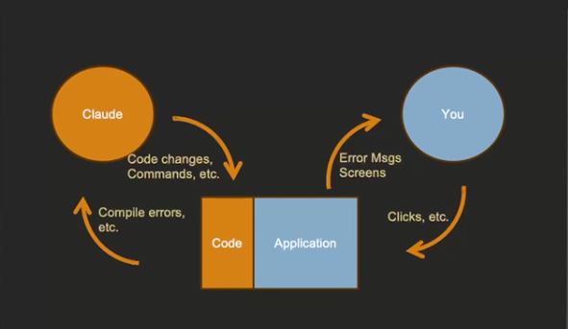

Ensuring Claude Code Checks Its Own Work May 1, 2026
This course content focuses on ensuring high-quality AI-generated code by implementing feedback and testing processes.
Importance of Feedback and Testing
- Avoid basic mistakes by instructing AI to seek feedback on its code changes.
- Human time is valuable; minimizing errors from AI-generated code prevents wasted effort.
Automated Quality Assurance Processes
- Require AI to always compile code, run tests, and verify that code passes before committing.
- Use automated tools like linters, compilers, and test suites to validate code independently.
Setting Clear Ground Rules in CLAUDE.md
- Document essential rules such as writing tests for new code and running tests before commits.
- Establish a loop where AI writes code, tests it, and ensures correctness before handing it off to humans.
Software Design, Token Limits, and Maintainability May 1, 2026
This course content explains the importance of software design when working with AI-assisted coding tools like Claude Code, focusing on the constraints and challenges posed by token limits.
Design Principles and AI Efficiency
- Good software design principles such as modularity, single responsibility, and isolation help make AI-assisted changes easier and more efficient.
- Proper design reduces the number of files and code segments the AI needs to analyze and modify, fitting within token limits and minimizing ripple effects.
Token Limits and AI Processing Constraints
- AI models have input and output token limits, restricting how much code can be processed or generated at once.
- Large projects or files exceeding these token limits make it difficult for AI to identify necessary changes or rewrite code in one pass, leading to inefficiencies.
Impact on Software Architecture and AI Labor
- Designing codebases with smaller, well-defined files and fewer dependencies helps AI quickly locate and update relevant code.
- Maintaining good design practices ensures scalability and maintainability when using AI as a development partner, requiring software engineers to translate their design skills into AI-friendly rules and processes.
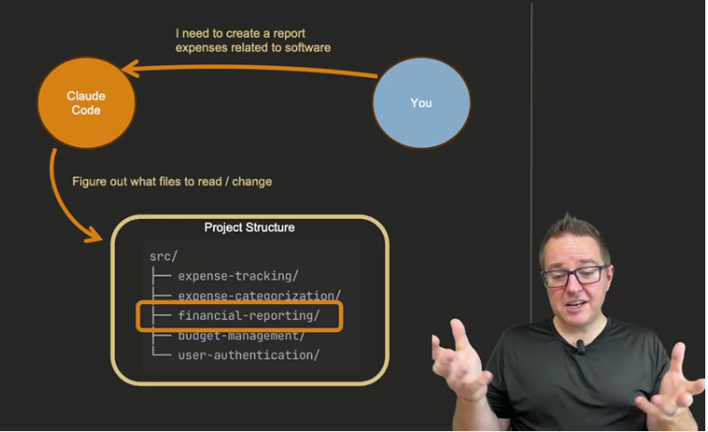

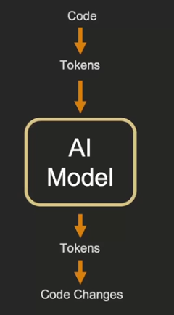
Having Claude Code Think & Plan First May 1, 2026
The course content emphasizes the importance of having Claude Code "think first" before coding to leverage its reasoning capabilities for better software development outcomes.
Planning Before Coding
- Claude Code's unique ability to analyze problems upfront helps avoid costly mistakes and design robust solutions.
- Saving detailed plans to files like FEATURE_PLAN.md preserves the design process for review, collaboration, and future reference.
Benefits of Thinking First
- Careful planning prevents architectural dead-ends and integration issues in complex development tasks.
- It is more efficient to correct mistakes in the planning phase than to fix problems after coding.
Extended Thinking Modes
- Claude Code offers multiple levels of thinking depth: "think," "think hard," "think harder," and "ultrathink," each providing more computational resources for thorough analysis.
- These modes help evaluate alternatives, consider edge cases, and develop comprehensive solutions before implementation.
Project Structure and File Naming is Critical Context for Claude Code Scalability May 1, 2026
This course content explains the importance of project structure and naming conventions in enabling AI tools like Claude Code to efficiently understand and modify software projects.
Project Structure and AI Discovery
- AI cannot assume all files at once; it must discover relevant files based on project structure.
- Clear folder and file naming help AI quickly locate where changes are needed without deep exploration.
Standard Naming Conventions and Token Efficiency
- Using common, standard naming conventions (e.g., store, slices, reducers) helps AI recognize libraries and functionality.
- Standard structures provide rich context with fewer tokens, making AI prompting more efficient.
Impact on AI-Assisted Development
- Well-structured projects aligned with prompt terminology make AI tasks easier and faster.
- Avoiding unusual or custom naming reduces the need for extra documentation and improves AI accuracy in code changes.
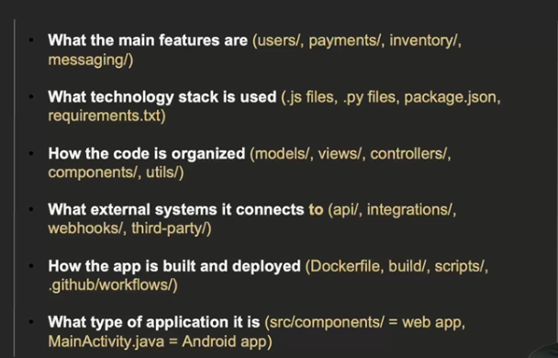

Exercise: From Coffee-Stained Napkin to Production Code with Multimodal Prompting May 1, 2026
This course content focuses on using Claude Code, an AI tool, to transform visual sketches and designs into production-ready software code, enhancing productivity and communication in software development.
Transforming Sketches into Code
- Claude Code can convert rough sketches, like a coffee-stained napkin design for an expense insights dashboard, into functional React components.
- The process involves saving the sketch as an image and prompting Claude Code to implement the design directly, streamlining UI development.
Advantages of Visual Communication in Development
- Visuals such as wireframes, mockups, and diagrams communicate UI layouts, color schemes, responsive behavior, and data visualizations more effectively than verbose text descriptions.
- Visual aids reduce misinterpretation and save time by clearly showing spatial relationships, color palettes, chart styles, and user flows.
Applications of Visual Communication
- Visuals help in various development stages including design handoffs, bug reporting, stakeholder communication, code reviews, and documentation.
- Using images for complex concepts like system architecture, database schemas, business logic, and performance profiling improves clarity and accelerates development workflows.
Start By Fixing the Process & Context, Not the Code May 1, 2026
This course content focuses on how to effectively work with Claude Code, an AI-assisted software development tool, by programming the process and context rather than just editing code directly.
Programming the Process and Context
- Instead of manually fixing code generated by Claude, update the Claude.md files and command files to improve instructions and context.
- Editing these files creates repeatability and scalability, allowing Claude to produce better code autonomously over time.
Improving Scalability and Repeatability
- Refining Claude.md and command files leads to a more trustworthy and scalable AI development process.
- The goal is to reduce hands-on code editing by improving the underlying prompts and instructions that guide Claude.
Handling Mistakes and Refinement
- When Claude makes mistakes, prompt it to fix the code to understand what additional context or instructions are needed.
- Use these insights to update the Claude.md and command files, enhancing the overall process for future tasks.

